< FOOD MANAGEMENT SYSTEM

**Use-Case Specification: Cancel orders**

Version <1.0>

Revision History

|  |  |  |  |
| --- | --- | --- | --- |
| **Date** | **Version** | **Description** | **Author** |
| <7/12/2020> | <1.0> | <details> | <Nguyen Thu Trang> |

Table of Contents

1. Use-Case Name 4

1.1 Brief Description 4

2. Flow of Events 4

2.1 Basic flow 4

2.2 Alternative flow 4

2.2.1 <First Alternative flow> 4

2.2.1 <Second Alternative flow> 4

3. Special Requirement 4

3.1 <First Special Requirement> 4

4. Preconditions 4

4.1 <Precondition One> 4

5. Posstcondition 4

5.1 <Postcondition One> 4

6. Extension Points 4

6.1 < Name of Extension Points> 5

**Use-Case Specification: Cancel orders**

1. **Cancel orders**
   1. **Brief Description**

This use case defines the step of **Cancel orders**. Customers cancel order that they have order

* 1. **Actor**

Customer

1. **Flow of Events**
   1. **Basic Flow**

First, admin click on manage product button. The system display  product view. Admin will input information about new product (id, name, price, brand, etc) need to be edited. Admin click on Save to confirm change. After, system will update product information

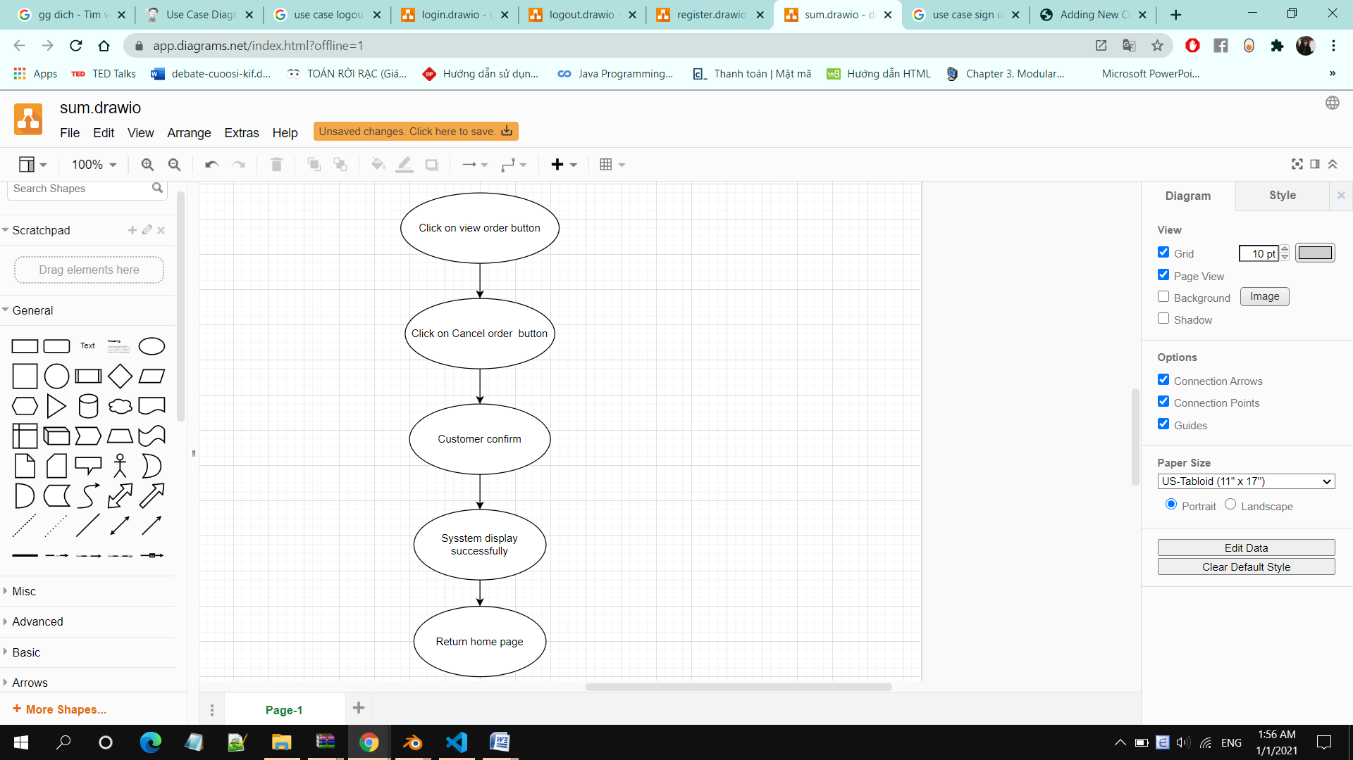

1. **Special Requirements**

None

1. **Preconditions**

Customers have ordered successfully and viewed order status

1. **Postconditions**

Canceled order

1. **Extension Points**

No extension points.